## Overview of Lab #2: Odometry

*ECSE 211: Design Principles and Methods*

# SECTION 1: DESIGN EVALUATION

Figure 1: robot design Figure 2: Axis orientation

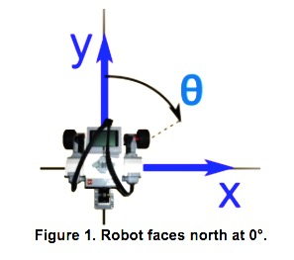

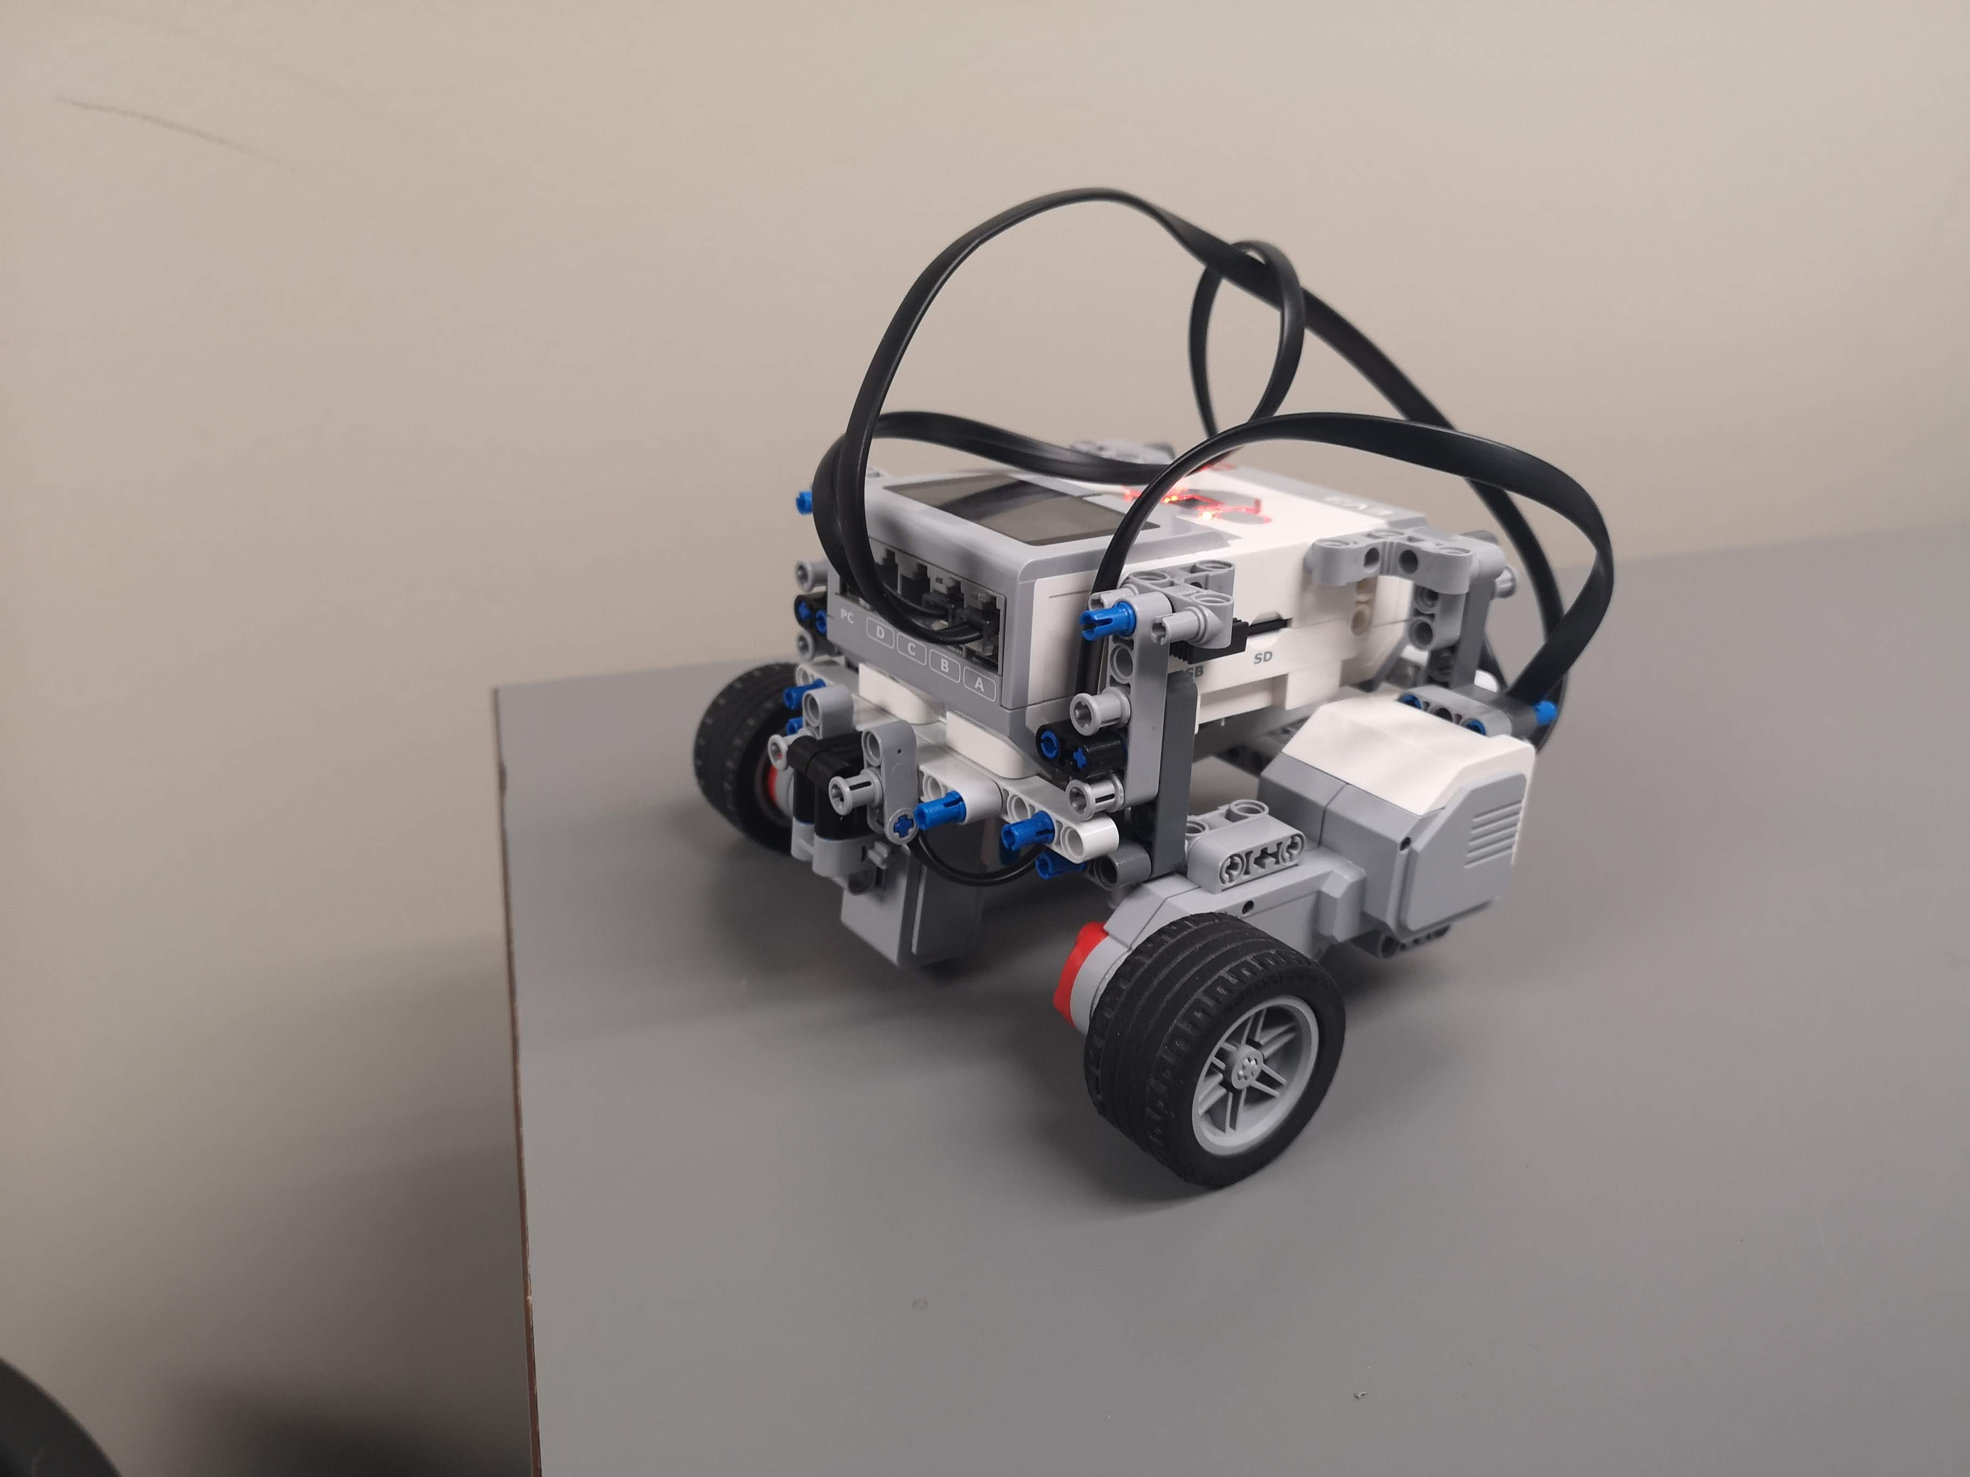

Color Sensor

Motor

For the hardware component of this lab, the two wheels (and their motors) are placed outwards on either side of the EV3. Since the wideness of the robot’s turns was not an issue for this project, the wheels could effectively be placed widely and assure the stability of the robot. The color sensor is placed at the mid point between the two wheels, at only one centimeter from the ground. This placement was designed in order to minimise noise and to assure the sensor correctly detects the line.

As for the software component of the lab, the correction odometer is used in order to complete the circuit. The correction is applied by using the color sensor to detect the black lines of the square grid. Tracking the crossing of the lines permits to reset the distance values according to the robots progress. The distance value X is due east and the Y distance is due north. This is done once during the lap, at the first line crossing for the Y variable and at the 4th for the X variable. The length of the tiles is then used to estimate the distance traveled by the robot. The values of the sensor are processed through a differential filter in order to counter the effect of poor lighting.

# SECTION 2: TEST DATA

**Table 1: Odometer test**

The first table presents the measured distance of the robot’s position as well as the distance display by the odometer for 10 independent trials in a 3x3 square without using odometry correction.

|  |  |  |  |  |
| --- | --- | --- | --- | --- |
|  | Measured distance (cm) | | Odometer distance (cm) | |
| Trial # | X | Y | X | Y |
| 1 | -2.1 | -3.6 | 0.87 | -0.82 |
| 2 | 0.8 | -1.6 | 0.81 | -1.01 |
| 3 | -2.7 | 2.6 | 0.78 | -0.42 |
| 4 | -3.2 | 2.3 | 1.04 | -0.75 |
| 5 | -0.8 | 0.2 | 0.72 | -0.45 |
| 6 | -1.9 | 3.1 | -0.62 | 1.71 |
| 7 | -2.2 | -2.3 | -1.02 | -1.04 |
| 8 | 2.2 | -2.5 | 1.01 | -1.19 |
| 9 | -1.5 | -0.7 | 0.32 | -1.31 |
| 10 | 1.8 | -1.9 | 2.41 | -2.62 |

**Table 2: Odometer correction test**

The second table presents the measured distance of the robot’s position as well as the distance display by the odometer for 10 independent trials in a 3x3 square with the use of odometry correction.

|  |  |  |  |  |
| --- | --- | --- | --- | --- |
|  | Actual Measure | | Display Measure | |
| Trial # | X | Y | X | Y |
| 1 | -13.4 | -14.3 | -13.21 | -13.63 |
| 2 | -13.7 | -14.2 | -12.01 | -12.21 |
| 3 | -12.5 | -17.3 | -10.55 | -14.19 |
| 4 | -16.1 | -12.7 | -14.47 | -14.55 |
| 5 | -14.5 | -14.9 | -15.67 | -15.25 |
| 6 | -15.3 | -12.6 | -15.31 | -12.63 |
| 7 | -15.3 | -15.2 | -16.19 | -22.86 |
| 8 | -13.3 | -9.5 | -13.96 | -14.24 |
| 9 | -15.9 | -9.6 | -15.74 | -13.96 |
| 10 | -12.7 | -10.4 | -12.43 | -10.98 |

# SECTION 3: TEST ANALYSIS

The Euclidean error distance ε of the position was calculated for every trial using the equation (1). The Euclidean error is a good method of determining the order of the error, as it takes into account the error in X as well as in Y. In the following equation, Xm is the measured value of X and Xo is the value of X displayed by the odometer.

|  |  |  |
| --- | --- | --- |
|  | $$ε=\sqrt{{\left(X_{m}-X_{o}\right)}^{2}+{\left(Y_{m}-Y_{o}\right)}^{2}}$$ | (1) |

The mean μ of the errors in X and Y were calculated using the absolute values of the errors as seen in equation (2). This was done as the errors in the odometer’s measure alternated regularly between positive and negative values. These errors would therefore cancel out if the signed values were used. The mean of the Euclidean error was calculating using the same equation, although it only comprised positive values. In the following equation, Zi is the error for each trial and N is the number of trials.

|  |  |  |
| --- | --- | --- |
|  |  | (2) |

The standard deviation σ of the errors in X and Y as well as of the Euclidean error were calculated used equation (3). The standard deviation formula gives the average deviation of each error in comparison to the mean of all errors. This gives an idea of how large is the variation between the errors. In the following equation, Zi is the error for each trial, N is the number of trials and μ is the mean.

|  |  |  |
| --- | --- | --- |
|  | $$σ=\sqrt{\frac{1}{N}\sum_{i=1}^{N}{{(Z_{i}-μ)}^{2}}}$$ | (3) |

**Table 3**

The third table presents the error in X and Y as well as the Euclidean error for every trial without correction. The average and standard deviation of these errors is also included.

|  |  |  |  |  |  |  |  |  |  |  |  |  |
| --- | --- | --- | --- | --- | --- | --- | --- | --- | --- | --- | --- | --- |
| Trial # | 1 | 2 | 3 | 4 | 5 | 6 | 7 | 8 | 9 | 10 | Mean | Std  Dev |
| Error x | -2.88 | -0.01 | -3.49 | -4.04 | -1.53 | -1.30 | -1.18 | 1.19 | -1.80 | -0.60 | 1.80 | 1.17 |
| Error y | -2.78 | -0.59 | 3.02 | 3.05 | 0.65 | 1.40 | -1.26 | -1.31 | 0.60 | 0.70 | 1.54 | 0.68 |
| Error ε | 4.00 | 0.59 | 4.61 | 5.06 | 1.66 | 1.91 | 1.72 | 1.77 | 1.90 | 0.92 | 2.51 | 0.47 |

**Table 4**

The third table presents the error in X and Y as well as the Euclidean error for every trial with correction. The average and standard deviation of these errors is also included.

|  |  |  |  |  |  |  |  |  |  |  |  |  |
| --- | --- | --- | --- | --- | --- | --- | --- | --- | --- | --- | --- | --- |
| Trial 3 | 1 | 2 | 3 | 4 | 5 | 6 | 7 | 8 | 9 | 10 | Mean | Std  Dev |
| Error x | -0.19 | -1.69 | -1.95 | -1.63 | 1.17 | 0.01 | 0.89 | 0.66 | -0.16 | -0.27 | 0.86 | 0.50 |
| Error y | -0.67 | -1.99 | -3.11 | 1.85 | 0.35 | 0.03 | 7.66 | 4.74 | 4.36 | 0.58 | 2.53 | 1.06 |
| Error ε | 0.70 | 2.61 | 3.67 | 2.47 | 1.22 | 0.03 | 7.71 | 4.79 | 4.36 | 0.64 | 2.82 | 0.71 |

*How do the mean and standard deviation change between the design with and without correction? What causes this variation and what does it mean for the designs?*

The error in X is greatly reduced when using the odometer correction compared to when using the odometer without correction. Indeed, the mean error improves from 1.8 cm to 0.86 cm and the standard deviation reduces from 1.17 to 0.5. This improvement was to be expected, as the goal of applying a correction to the odometer is to get a more accurate result. The improvement is due to the value of X being updated once during the lap, meaning that the value of X displayed is determined from more information further in the lap.

On the other hand, the error in Y has proven to be substantially worse from the testing of the odometer correction. The mean error in Y without correction is of 1.54, and the mean with correction is of 2.53. The augmentation of a whole average centimeter of error is unexpected but proved to be very constant during the testing of the robot. One explanation as to why this result is so dissatisfactory is most likely due to the conception of our software. As it will be explained in the next question below, the real distance value of Y is updated very early in the lap meaning the robot has a bigger opportunity to deviate and for the odometer to give an erroneous Y measurement.

*Given the design which uses correction, do you expect the error in the X direction or in the Y direction to be smaller?*

The X direction (horizontal) is expected to have a smaller error that the Y direction (vertical) when using the corrected odometer. This is due to the fact that the value of Y is rest after the first crossing of a line. This means that after the 7 other tiles are crossed, the distance display by the odometer is simply the addition of the length of the tiles crossed. On the other hand, it is only after the first corner is turned that the value of X is rest. Subsequently only 5 other tiles are crossed, meaning that the value displayed has a smaller window of error, as it travels a longer distance before the correction as opposed to after. This proved to be true given the test results.

# SECTION 4: OBSERVATIONS AND CONCLUSIONS

*Is the error you observed in the odometer, when there is no correction, tolerable for lager distances? What happens if the robot travels 5 times the 3-by-3 grid’s distance?*

The error from the odometer’s display would not be tolerable for large distances. Without the correction, the robot never receives information on its current position on the grid and therefore its errors are never rectified. Any error made by the odometer on the estimation of its position would be accumulated if the robot travelled 5 times a 3-by-3 grid. Indeed, an error made during the first lab would be used as the starting point for the next lap and so on. If the robot starts with an incorrect information if will only build on more mistakes by consequence.

*Do you expect the odometer’s error to grow linearly with respect to travel distance? Why?*

Yes it is expected that the error in the odometer would grow linearly with respect to the distance traveled as long as the error is considered in terms of its absolute value. For example, if the odometer of a robot consistently has an error of 2 cm, an error of 2 cm will be added to the total error after every lap completed. The travel distance will be off by 2 cm the first lap, by 4 cm the second, by 6 cm the third and so on. This gives a linear growth of the error over distance.

# If it was not the absolute error but instead the relative error that was taken into account, then the error would not grow linearly. Since the error of the odometer is always measured in the context of this lab in terms of absolute, it is indeed more appropriate to consider it in this matter. The error is therefore linear.

# SECTION 5: FURTHER IMPROVEMENTS

*Propose a means of reducing the slip of the robot’s wheels using software.*

Although the issue of reducing the slip of the robot’s wheels could be easily solved by altering the hardware of the robot through a numerous of approaches, the problem is much more difficult to address using software. One of the most affective and simple solutions using software would be to reduce the acceleration of the robot, since a lower acceleration of the robot results in less force being applied to the floor, which reduces slip. This can be achieved by reducing the speed of the robot, which will then it turn reduce the amount of acceleration needed.

*Propose a means of correcting the angle reported by the odometer using software when:*

* *The robot has two light sensors*

If the robot has two light sensors, then a very effective way of correcting the reported angle of the odometer is to put a sensor in front of each of the two wheels of the robot. By doing so, it is possible to calculate the amount of time it takes for each sensor to reach the next line. When both wheels are turning at the same speed, if both sensors take the same amount of time to reach the next line, then the robot is moving in a direction that is perfectly perpendicular to the lines. If a sensor crosses faster, then the robot is angled towards the wheel of which the faster sensor corresponds to. This angle can be easily calculated using simple trigonometry and the distance in function to time and speed.

* *The robot has only one light sensor*

A way of improving the reported angle would be to have the robot complete a circle around a single tile on the floor. By having the robot leave and enter the square on each of its sides during the circling, it is possible to gather information on its position based on the scanning of eight lines. As seen in figure 3, the robot (blue trajectory), would cross the lines of the squares on eight different points and based on this information the robot can accurately determine its absolute location. Then, using simple trigonometry and the length of the tile, it is possible to find the angle theta of the robot. The only equation that is needed is the equation 4 given below.

Figure 3

|  |  |  |
| --- | --- | --- |
|  | $$θ=arccos⁡\left(\frac{tile length}{distance travelled}\right)$$ | (4) |